
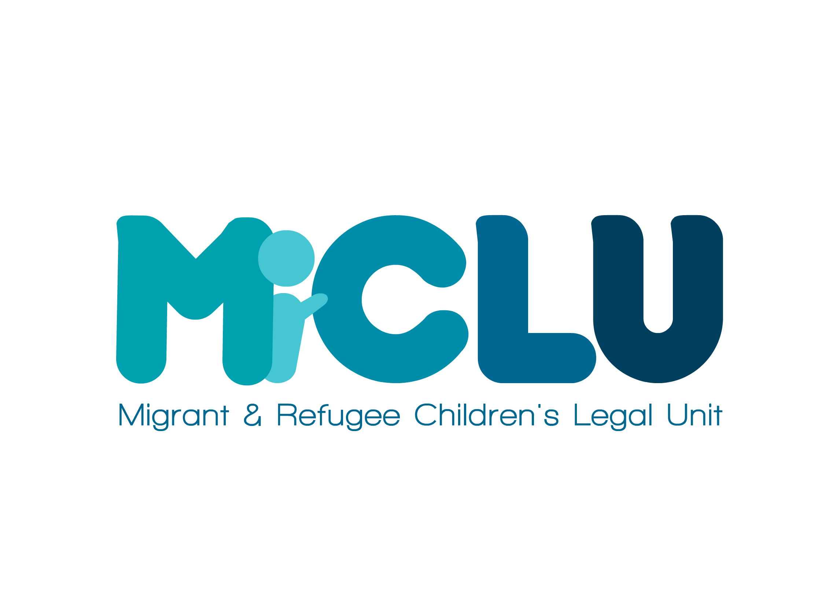

Background Information about the Law Centre and MiCLU

About MiCLU

MiCLU is a project of Islington Law Centre. MiCLU works closely with Islington Law Centre’s team of lawyers leading and developing specialist legal services aimed at upholding and improving the rights of children and young people. We offer a direct casework service, providing specialist legal advice and representation to children and young people adopting a child-centred and trauma-informed approach to our legal work in order to meet the complex needs of our young clients. We use learning from our casework to inform our policy advocacy work to ensure that policy makers consider the specific impact of laws and policy upon children and young people, and to ensure that the voices of children and young people inform discussions in this regard, and that their experience is reflected in discussions about policies affecting them. We also develop legal education with and for children and young people and the professionals that work with them promoting the use of child-friendly information and the adhering to the concept ‘Nothing about us without us’ – children and young people must be involved in the delivery of training to peers and professionals.
Our work is led by the views and experiences of our young clients who continue to inspire and develop our services. Together we are committed to educating young people about their rights and being educated by them about their lived experience of the immigration and asylum system. We work in partnership with carers and professionals dedicated to helping young people live safe and protected lives in the UK, we seek to offer support to and to learn from those agencies which are user led and informed by the voices of children and young people.
We believe that the law can be used as an effective tool to create social change and we are committed to working with children and young people and those agencies representing them to campaign and advocate for child and youth-centred legal processes and systems. We also believe that by building collaborations and partnerships between individuals, organisations, statutory and non-statutory agencies across different professional disciplines we can work together to tackle and address the complex realities, challenges and injustices faced by young people whose lives are governed by complex laws, ensuring that they are treated as children first and foremost. The voices of children and young people with lived experience of the asylum and immigration systems are rarely heard properly within it. This results in harm to children and young people and the perpetuation of systems that do not offer adequate protection for vulnerable children and young people. We are committed to working with children and young people to amplify their voices within these systems and to identify opportunities for them to have their voices heard. In our experience when children and young people’s voices are properly heard, this can make change happen.

About Islington Law Centre

Islington Law Centre is a full member of the Law Centres Network (LCN) and participates fully in joint initiatives and policy development in partnership with other Law Centres.

The Law Centre currently employs 35 people, and is based in offices near the Angel, in the south of the London Borough of Islington.

The Law Centre receives funding from the local authority, the Legal Aid Agency (with whom we have contracts to provide publicly funded Legal Aid), City of London law firms, Charitable Trusts, Foundations and donations.

We are a Registered Charity and a Company Limited by Guarantee. Our turnover is in the region of £1.5 million per annum.

Services Provided

The Law Centre holds the Law Society’s Lexcel Quality Mark, which is subject to an annual independent audit process. The Law Centre is contracted to provide publicly funded legal advice and representation by the Legal Aid Agency in the following areas of law; Immigration & Asylum, Housing, Debt and Welfare Benefits, and Public Law, and to manage the Duty Desk Scheme at Clerkenwell and Shoreditch County Court. The Law Centre’s wider Immigration & Asylum Team (incorporating our Community Facing Team and the Migrants Law Project) has received a Category 1 independent Peer review from the Legal Aid Agency, this review encompassed MiCLU’s legal casework. More recently MiCLU’s legal aid casework was individually rated Category 1 at Peer Review.

In addition to providing publicly funded work we offer services funded by other sources in: Community Care, Consumer, Debt, Education, Employment, Housing, Immigration and Asylum, Public Law and Welfare Benefits.

The Law Centre has good links with a number of London City law firms, and operates evening advice sessions for people with consumer and small claims issues, which are staffed by volunteer solicitors from partner firms. These sessions are held on Monday, Tuesday and Wednesday evenings.

We offer telephone advice support to local community organisations, and work closely with a range of other agencies, including user led and unfunded groups.

The Law Centre is a founding member of Islington Advice Alliance, and has close working links with Islington People’s Rights, Citizens Advice Service, and Help on Your Doorstep.

Staff Structure and Volunteers

The Law Centre’s Senior Management Team consists of a Director and Deputy Director. The Directors are jointly responsible to the Board of Trustees for the day to day running of the organisation.

The Law Centre staff is currently comprised of 18 staff members who are qualified as solicitors or barristers, the majority are practising solicitors with many years PQE, 10 specialist caseworkers, an Office Manager, Reception and Referral staff and project support staff. We engage a qualified accountant to oversee our finances.

We have at least one Supervisor for all areas of law practised with the majority of areas having two in order to provide continuity during periods of holiday or absence.

Board of Trustees

The Board of Trustees currently has 9 members, some of whom have been on the Board for a number of years, and some who are fairly new to this role. The Board includes lawyers with an interest in the work of the Law Centre, and other members with relevant skills and experience.

The Director and Deputy Director are responsible for liaising with the Board and meetings are held approximately every 8 weeks, during the evening.

The Board provides oversight and governance of the Law Centre, and members hold formal responsibility as Directors of the Company and Trustees of the Charity.

Plans for the Future

Islington Law Centre is proud to have represented the most marginalised and excluded members of our community for almost 50 years ensuring that they are housed, able to access the resources they need and are not at risk of removal to countries where their human rights would be violated. Despite an increasingly challenging funding and legislative environment the Law Centre has continued to develop ground-breaking services across a range of areas of law and has been involved in legal challenges that have overturned attempts to reduce the scope of legal aid.

We have been able to develop a number of innovative and creative solutions to the emerging needs of clients, and have a number of priorities for the future which include:

- Continuing to undertake strategic litigation and policy and advocacy work on behalf of our client groups;
- Updating and improving our Mission, Objectives and Values;
- Improving our infrastructure, particularly ICT as part of the joint initiative by the Law Centres Network, to ensure that we can maintain the quality of our work and strengthen our relationships with funders, donors and supporters;
- Increasing our unrestricted income, so that we can build our reserves and adapt in a changing funding climate;
- Securing funding to maximise the capacity of our casework teams as we are experiencing very high demand for our services;
- Building our joint work with other organisations to maximise the impact of our work; and
- Building on our reputation as a Law Centre which provides high quality legal representation to our community.

